**Project report – 3**

**Mobile App for Disease Detection in Sugarcane**

Date: 21/06/2024

Project duration: 19th to 21st June 2024

Organization name: Garuda Aerospace

# Introduction

## Background

Timely and accurate detection of diseases in crops is crucial for ensuring healthy yields and minimizing losses. Advances in mobile technology and machine learning have paved the way for innovative solutions in agricultural monitoring.

## Purpose

The purpose of this project is to develop a mobile application capable of detecting diseases in sugarcane leaves using machine learning models integrated into MIT App Inventor.

# Project Objective

The main objective was to create a user-friendly mobile app that can detect and classify diseases in sugarcane leaves, aiding farmers in early identification and management of crop diseases.

# Project Scope

## Scope

The project involved designing the app interface, integrating a machine learning model, and testing its functionality in detecting sugarcane leaf diseases.

## Deliverables

A functional mobile app capable of identifying healthy and diseased sugarcane leaves, along with documentation and usage guidelines.

# Methodology

## Approach

* Creating an interface of the app in MIT app inventor
* Building the model in Personal Image Classifier, an extension of MIT app inventor
* Integrating the model to the app using the same
* Testing

## Tools/Technologies

* MIT App Inventor: For designing the app interface and integrating the machine learning model.
* Personal Image Classifier: To build and train the machine learning model for disease detection.
* Android Device: For testing the application

# Project Execution

## Timeline

* 19th June 2024 – building interface
* 20th June 2024 – building and tuning model
* 21st June 2024 – integrating model with interface

# Outcomes and Results

## Results

The project successfully developed a mobile app that can detect and classify diseases specifically red rot, mosaic, yellow and rust in sugarcane leaves with high accuracy. The app provides immediate feedback to the user, aiding in early disease detection and management.

## Impact

This tool can significantly benefit farmers by providing a quick and reliable method for monitoring the health of their crops, ultimately leading to better crop management and yields.

# Challenges and Solutions

## Challenges

Initial integration of the machine learning model posed some difficulties, and achieving high accuracy required extensive testing and refinement.

## Solutions

Utilized comprehensive testing and feedback loops to refine the model and improve detection accuracy. Leveraged online resources and tutorials for troubleshooting and optimizing the app functionality.

# Lessons Learned

## Learning Points

The project highlighted the importance of a user-friendly interface and the challenges of integrating machine learning models into mobile applications. Iterative testing and refinement are crucial for ensuring accuracy and usability.

## Improvements

Future iterations could focus on enhancing the model's accuracy further, adding more disease classes, and improving the app's performance.

# Conclusion

## Summary

The project successfully created a mobile app for detecting sugarcane leaf diseases using machine learning. The app demonstrates the potential of mobile technology in agricultural disease management and sets the stage for further enhancements and broader applications.

## Future Work

Future efforts could include expanding the model to detect more diseases, improving accuracy, and integrating additional features such as GPS tagging and data logging.

# Appendices

## Websites used

* <https://appinventor.mit.edu/>
* <https://classifier.appinventor.mit.edu/>

## References

<https://youtu.be/b0pvffWfVBY?si=nXXcAhiQ7sPeN-Rg>

## Media

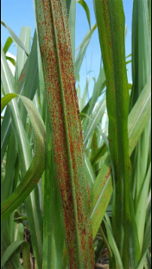 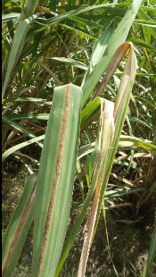 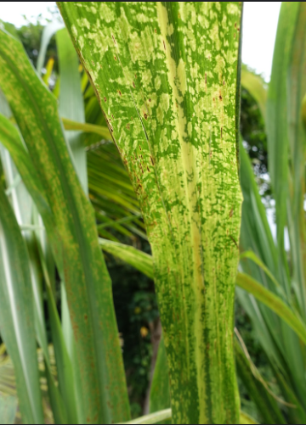 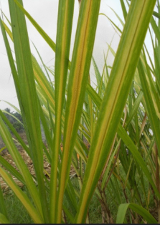 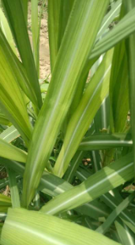

Rust Red rot Mosaic Yellow Healthy

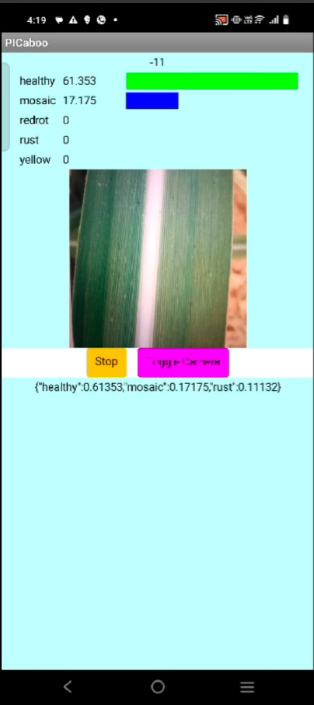 [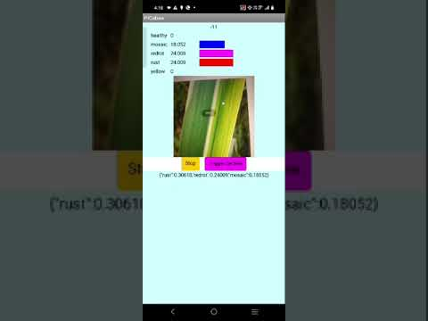](https://www.youtube.com/embed/So49iHwGrTc?feature=oembed)

Screenshot of app Working of app